|  |
| --- |
| Department of Labor  office of labor-management standards |
|  |
| **Simplified Annual Report** |
| Release v1.0 |
|  |

**Revision History**

|  |  |  |  |
| --- | --- | --- | --- |
| **Date** | **Revision** | **Description** | **Author** |
| **01/29/2018** | **1.0** | **Initial Draft** | **Bineeta Adityan** |
|  |  |  |  |
|  |  |  |  |

**Contents**

1. Background 5

2. Project Description 6

3. Purpose 6

3.1. Definitions, Acronyms, Abbreviations 6

3.2. References 6

4. FUNCTIONAL REQUIREMENTS 7

4.1. Login 7

4.2. Page Level Requirements 7

4.2.1. Report Listing 7

4.2.1.1. Start New form 7

4.2.1.1.1. Data load options 8

4.2.2. Page 1 – LOCAL UNIONS 9

4.2.2.1. Business Requirements 9

4.2.2.2. Functional Requirements 9

4.2.2.3. Header Section 9

4.2.2.4. Footer Section 10

4.2.2.5. Design 10

4.2.2.6. Requirements 10

4.2.2.7. Section/Field Level Requirements 10

4.2.2.8. Create Data File 12

4.2.2.9. Import 12

4.2.2.10. Validation Summary Section 13

4.2.3. Page 2 – CERTIFICATION 13

4.2.3.1. Business Requirements 13

4.2.3.2. Functional Requirements 13

4.2.3.3. Header Section 13

4.2.3.4. Footer Section 13

4.2.3.5. Design 13

4.2.3.6. Requirements 14

4.2.3.7. Section/Field Level Requirements 15

4.2.4. Other functionalities 17

5. Requirements Revisions History 18

# Background

Pursuant to 29 CFR 403.4(b) a local labor organization which is not in trusteeship and which has no assets, no liabilities, no receipts, and no disbursements during the period covered by the annual report of the national organization with which it is affiliated need not file an annual financial report if the following conditions are met:

(1) It is governed by a uniform constitution and bylaws filed on its behalf pursuant to §402.3(b) of this chapter, and does not have governing rules of its own;

(2) Its members are subject to uniform fees and dues applicable to all members of the local labor organizations for which such simplified reports are submitted;

(3) The national organization with which it is affiliated assumes responsibility for the accuracy of, and submits with its annual report, a separate letter-sized sheet for each local labor organization containing the following information with respect to each local organization in the format illustrated below as part of this regulation:

(i) The name and designation number or other identifying information;

(ii) The file number which the Office of Labor-Management Standards has assigned it;

(iii) The mailing address;

(iv) The beginning and ending date of the reporting period which must be the same as that of the report of the national organization;

(v) The names and titles of the president and treasurer or corresponding principal officers as of the end of the reporting period;

(vi) The names and titles of the officers as of the end of the reporting period;

(4) At least thirty days prior to first submitting simplified annual reports, the national organization notifies the Office of Labor-Management Standards, Division of Reports Processing and Disclosure, U.S. Department of Labor, 200 Constitution Avenue N.W., Washington, D.C. 20210, in writing, of its intent to begin submitting simplified annual reports for affiliated local labor organizations;

(5) The national organization files a terminal report on Form LM-3 clearly labeled on the form as a terminal report, for any local labor organization which has lost its identity through merger, consolidation, or otherwise if the national organization filed a simplified annual report on behalf of the local labor organization for its last reporting period; and

(6) The national organization assumes responsibility for the accuracy of and submits with its annual report and the simplified annual reports for the affiliated local labor organizations, the following certification in duplicate properly completed and signed by the president and treasurer of the parent national organization:.

# Project Description

The Electronic Forms System (EFS) is the Office of Labor-Management Standards’ (OLMS) web-based system for completing and submitting labor organization and other reports. The goal for the management is to make the system available to all other annual reports to help reduce the number of paper submissions.

# Purpose

The purpose of this project is to create the electronic version of the Simplified Annual Report via the EFS system.

# Definitions, Acronyms, Abbreviations

The following is a list of commonly used acronyms used throughout this document:

| Term | Definition |
| --- | --- |
| DOL | Department of Labor |
| e.LORS | Electronic Labor Organizations and Reports System |
| FRD | Functional Requirements Document |
| OLMS | Office of Labor-Management and Standards |
| OMB | Office of Management and Budget |
| PO | Program Office |
| RD | Regional Director |
| SQL | Structured Query Language |
| EFS | Electronic Filing System |
| LM | Labor Management |
| ORTS | OLMS Report Tracking System |
| LMRDA | Labor-Management Reporting and Disclosure Act |
| Filer | Users who prepare and sign the form |
| Preparer | Users who prepare the form |
| HTML link | Hypertext Markup Language link |
| DIS | Division of Interpretations and Standards |

# References

* OLMS Reporting and Disclosure page

<https://www.dol.gov/olms/regs/compliance/interp_manual/200_IM_RND.htm>

# FUNCTIONAL REQUIREMENTS

* Simplified Annual Report will be available within the OLMS EFS Web Application.
* Only unions with designation name as “National Headquarters” can file the Simplified Report.
* The preparer or filer shall register his/her user account in EFS system to prepare, complete the form.
* Only filer who has authority to sign should be able to sign the Simplified Report.
* The system will have the field level and form level validation rules to authenticate the data before the submission.
* Only the signed form can be finally submitted.

# Login

The EFS system will have a link to navigate to the Simplified Report user interface. The filer or preparer who is associated to a national organization may create a new account or may use an already existing account to access the form.

# Page Level Requirements

Page level requirements and the validation rules for each page are detailed throughout this document.

# Report Listing

The Simplified Report will be listed in the annual report listing section. The report will be available only to the filers associated to the national organization filing the report.

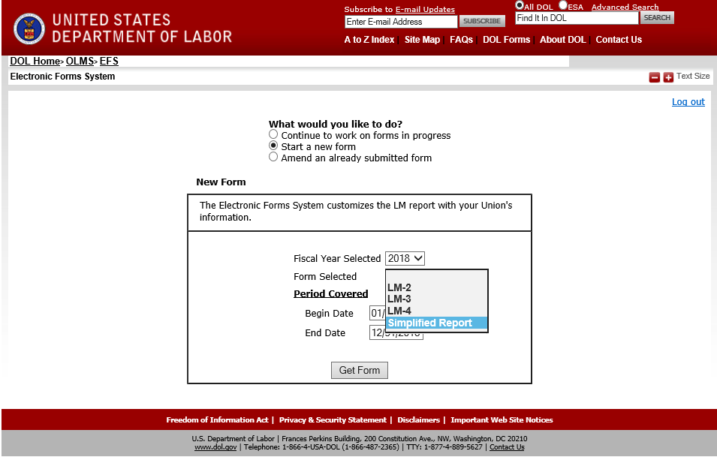

# Start New form

To start a new form, the following data entries are required.

* **Fiscal Year Selected** – This will be drop down listing the fiscal year in YYYY format.
* **Form Selected** - This will be a drop down listing all available electronic forms, including “Simplified Report”.
* **Period Covered** – This items will have the following fields listed.
  + **Begin Date** – This will be a date field. The filer will enter the date in MM/DD/YYYY format. The begin date should be within the fiscal year that the filer selected. The date should not be a future date.
  + **End Date** – This will be a date field. The filer will enter the date in MM/DD/YYYY format. The end date should be within the fiscal year that the filer selected. The date should not be a future date.
* **Get Form** – Button to navigate to the form.

# Data load options

When selecting the “Simplified Report” the system will provide the following options to the filer.

1. **Prepopulate with data submitted for <*Fiscal Year of the last successfully submitted report by this filer> based on current OLMS union data (***e.g. Prepopulate with data submitted for 2018 *based on current OLMS union data****)*** - Selecting this option will pre-populate the data submitted for the last fiscal year in the form.
   * For the first time filers, (filers who have never submitted Simplified Annual Report), selecting this option should display the following message.

“<Filing National Organization’s name> appeared to be a first time Simplified filer. Please click “Start a new form” to proceed.”

* + When the returning filers use this option and when clicking the “Get Form” button, the system should do the following steps:

1. System will get the previous year’s simplified listing report submitted by the labor organization. The system will pull the following data from the database at this time:
   * The local union’s file number and the officer’s names from the previous year’s report.
   * The system will pull the Designation Name, Designation Prefix, Designation Number, Designation Suffix and Unit Name of each local union from ID_union table.
   * Replace the period covered with the new dates that the filer entered.
   * Any local union that terminates during the period covered of the simplified report that is being filed should be removed (this data should not be included in the list).
2. The following pop-up will be displayed for the user:

The EFS system will populate the fields Designation Name, Designation Prefix, Designation Number, Designation Suffix and Unit Name of each local union listed as a courtesy. Changes to this data will not be recorded by OLMS. If you need to make any changes to this data, please contact the OLMS help desk at 1-866-401-1109.”

1. The system will populate these data in the Local Union page.
2. **Export data for <NHQ’s name> local unions based on current OLMS’ union data** (e.g. Export data for AFL_CIO’s local unions based on current OLMS’ union data) - Option to export the data from the latest report submitted by the filer out to excel spreadsheet. The system should find the last successfully submitted data and the download the data to an excel spreadsheet.
   * For the first time filers, (filers who have never submitted Simplified Annual Report), selecting this option should display the following message.

“<Filing National Organization’s name> appeared to be a first time Simplified filer. Please click “Start a new form” to proceed.”

* + When the returning filers use this option and when clicking the “Get Form” button, the system should do the following steps:

1. System will get the previous year’s simplified listing report submitted by the labor organization. The system will pull the following data from the database at this time:
   * The local union’s file number and the officer’s names from the previous year’s report.
   * The system will pull the Designation Name, Designation Prefix, Designation Number, Designation Suffix and Unit Name of each local union from ID_union table.
   * Replace the period covered with the new dates that the filer entered.
   * Any local union that terminates during the period covered of the simplified report that is being filed should be removed (this data should not be included in the list).
2. The system will download these data to an Excel spreadsheet and will navigate the user to a new form.
3. **Start a new Form** - This option will open a new blank form for the filer to manually type of import the data.

# Page 1 – LOCAL UNIONS

# Business Requirements

Page 1 lists the information related to the national organization who is filing the report and the listing of the local unions under the national organization.

# Functional Requirements

System shall display ‘Page 1’ in the following states.

* When the filer successfully open a Simplified Annual Report form.
* When the filer selects the “<” (PREVIOUS)’ button on Page 2, ‘Certification’.
* When the filer selects the ‘LOCAL UNIONS’ link from Left Navigation Panel

# Header Section

The header and footer items pictured below will be displayed on Page 1.

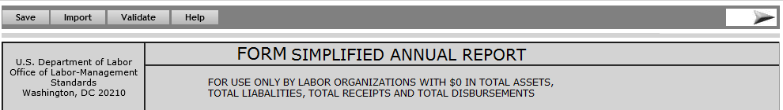

# Footer Section



# Design

A mock-up design for Page #1 is displayed below.

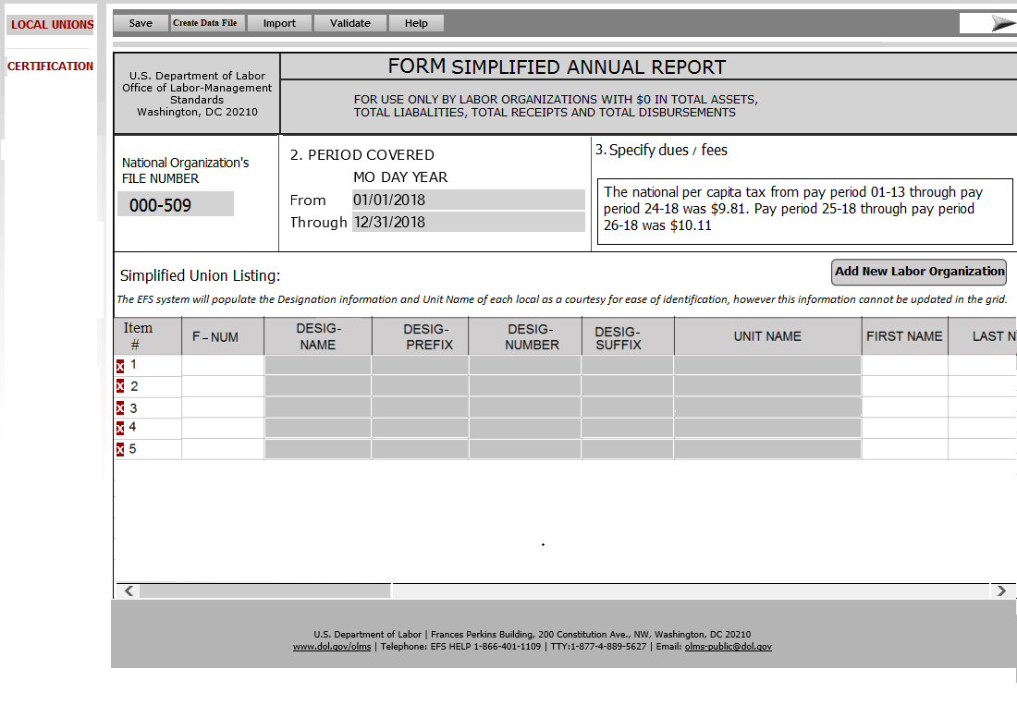

# Requirements

The LOCAL UNIONS page is the landing page. The system will pre-populate some of the fields upon loading the page.

# Section/Field Level Requirements

* **National Organization’s FILE NUMBER** - The system shall pre-fill the file number of the national organization who is filing the report. This field will be read-only.
* **2. Period Covered By This Report:** - The following two date fields will be listed in this section.
  + **From:** - This will be the beginning date of the fiscal year covered in the report. This field will be pre-populated with the data that the filer entered when a new form is started. The format for the field should be MM/DD/YYYY. This field will be read-only on this page.
  + **Through:** - This will be the ending date of the fiscal year covered in the report. This field will be pre-populated with the data that the filer entered when a new form is started. The format for the field should be MM/DD/YYYY. This field will be read-only on this page.
* **3. Specify dues/fees** – This will be a text field to enter the information regarding the dues/fees.
* **Simplified Union Listing** – The followingfields in a grid line format will be listed in this section.

This section should list the following note on the header section:

“The EFS system will populate the Designation information and Unit Name of each local as a courtesy for ease of identification, however this information cannot be updated in the grid. If you need to make any changes to this data, please contact OLMS help desk at 1-866-401-1109”

* **Item #** – This will list the numbering of the grid line listed in this section. The field will be read-only.
* **F-NUM –** This will be a numeric field to enter the file number of each local union.
* **DESIGNATION NAME –** This field will be read-only. Upon saving the page, the system will populate the designation name of the labor organization listed in each line. The data will remain read-only.
* **DESIGNATION PREFIX -** This field will be read-only. Upon saving the page, the system will populate the designation prefix of the labor organization listed in each line. The data will remain read-only.
* **DESIGNATION NUMBER -** This field will be read-only. Upon saving the page, the system will populate the designation number of the labor organization listed in each line. The data will remain read-only.
* **DESIGNATION SUFFIX -** This field will be read-only. Upon saving the page, the system will populate the designation suffix of the labor organization listed in each line. The data will remain read-only.
* **UNIT NAME -** This field will be read-only. Upon saving the page, the system will populate the unit name of the labor organization listed in each line. The data will remain read-only.
* **FIRST NAME** - This will be a text field to enter the first name of the Union Officer associated to the local union.
* **LAST NAME -** This will be a text field to enter the Last name of the Union Officer associated to the local union.
* **P.O BOX** - This will be a numeric field in 5 +4 format (xxxxx-xxxx). The field will be pre-filled upon successful login. The filer will be able to modify the information.
* **STREET ADDRESS -** This will be a text field to enter the street address of the local union.
* **CITY** – This will be a text field to enter the city.
* **STATE** – This will be a drop-down field to enter the State. The drop down must list of all states code plus '00' for a non-state.
* **ZIP CODE** – This will be a numeric field in 5 +4 format (xxxxx-xxxx). The field will be pre-filled upon successful login. The filer will be able to modify the information.
* **PRESIDENT TITLE** – This will be a text field to enter the union official’s title.
* **PRESIDENT FIRST NAME -** This will be a text field to enter the first name of the union official.
* **PRESIDENT LAST NAME -** This will be a text field to enter the first name of the union official.
* **TREASURER TITLE -** This will be a text field to enter the title of the union official.
* **TREASURER FIRST NAME -** This will be a text field to enter the first name of the union official.
* **TREASURER LAST NAME -** This will be a text field to enter the first name of the union official.

# Create Data File

When filer click “Create Data File” button, the system should find the last successfully submitted data and the download the data to an excel spreadsheet. (The functionality will be the same as the export feature listed in the page Report Listing page.

* + For the first time filers, (filers who have never submitted Simplified Annual Report), selecting this option should display the following message.

“<Filing National Organization’s name> appeared to be a first time Simplified filer. Please click “Start a new form” to proceed.”

* + When the returning filers use this option, the system should do the following steps:

1. System will get the previous year’s simplified listing report submitted by the labor organization. The system will pull the following data from the database at this time:
   * The local union’s file number and the officer’s names from the previous year’s report.
   * The system will pull the Designation Name, Designation Prefix, Designation Number, Designation Suffix and Unit Name of each local union from ID_union table.
   * Should replace the period covered with the new dates that the filer entered.
   * Any local union that terminates during the period covered of the simplified report should be removed (this data should not be included in the list).
2. The system will download these data to an Excel spreadsheet and will navigate the user to a new form.

# Import

The system should provide an import feature to import the simplified union listing listed in Page#1. The filer should be able to import the data from an excel spreadsheet.

When the filer click **Import** button, the system should display the following message to the user. The import process will start when the filer click OK button on the pop-up message.

**“The EFS system will populate the fields Designation Name, Designation Prefix, Designation Number, Designation Suffix and Unit Name of each local union listed as a courtesy. Changes to this data will not be recorded by OLMS. If you need to make any changes to this data, please contact the OLMS help desk at 1-866-401-1109.”**

Data Validation – Any local union that terminates during the period covered of the simplified report should not get imported from the excel spreadsheet.

The import will import the data and will list any data validation error in the validation summary list.

# Validation Summary Section

The validation summary section will be listed along the side of this page.

* The Validation summary section shall list all errors, in the order of row number.
* Each error shall have the row number, column number and the error message.
* A hyper link will be provided for each error. When user selects this link system shall navigate the user to the row number and if possible to the field (cell) that has an error.

# Page 2 – CERTIFICATION

# Business Requirements

Page 2 lists the Certification text in a read-only format. The EFS system will pre-populate the details of the national organization in certain sections.

# Functional Requirements

System shall display ‘Page 2’ in the following scenarios.

* When the filer selects “>” (next)’ button on the ‘LOCAL UNIONS’ page.
* When the filer selects ‘CERTIFICATION’ link from the Left Navigation Panel.

# Header Section

The header section pictured below will be displayed on Page 2.



# Footer Section

The footer section pictured below will be displayed on Page 2.



# Design

A mock-up design for Page #2 is displayed below.

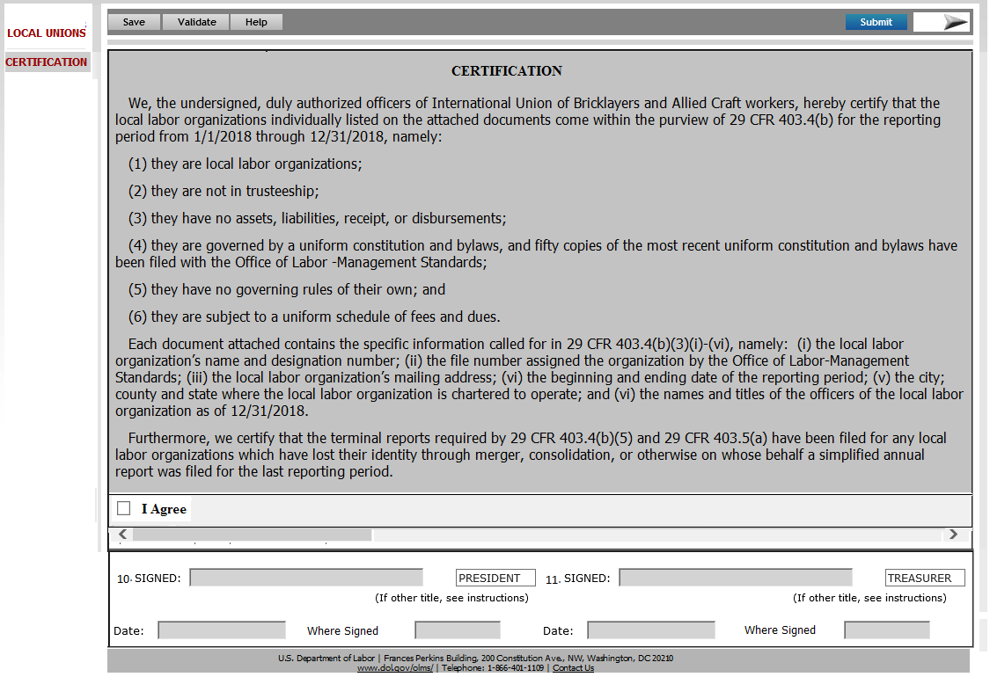

# Requirements

The page will list the certification text and the signature clock.

# Section/Field Level Requirements

* **Certification –** Following certification text in a read-only format. The information listed in the italics in the text below will be pre-populated by the system.

**CERTIFICATION**

We, the undersigned, duly authorized officers of <*Full name of the National Organization International filing this report*>, hereby certify that the local labor organizations individually listed on the attached documents come within the purview of 29 CFR 403.4(b) for the reporting period from <*Period Covered From Date*> through <*Period Covered End Date>*, namely:

(1) they are local labor organizations;

(2) they are not in trusteeship;

(3) they have no assets, liabilities, receipt, or disbursements;

(4) they are governed by a uniform constitution and bylaws, and fifty copies of the most recent uniform constitution and bylaws have been filed with the Office of Labor -Management Standards;

(5) they have no governing rules of their own; and

(6) they are subject to a uniform schedule of fees and dues.

Each document attached contains the specific information called for in 29 CFR 403.4(b)(3)(i)-(vi), namely:  (i) the local labor organization’s name and designation number; (ii) the file number assigned the organization by the Office of Labor-Management Standards; (iii) the local labor organization’s mailing address; (vi) the beginning and ending date of the reporting period; (v) the city; county and state where the local labor organization is chartered to operate; and (vi) the names and titles of the officers of the local labor organization as of 12/31/2018.

Furthermore, we certify that the terminal reports required by 29 CFR 403.4(b)(5) and 29 CFR 403.5(a) have been filed for any local labor organizations which have lost their identity through merger, consolidation, or otherwise on whose behalf a simplified annual report was filed for the last reporting period.

* **I Agree** - This will be a check box item. After successfully completing the validation, the filer needs to check this check box to sign the form. The signature block will not be enabled if the check box is not checked.
* **Signatures** –The signature section will be enabled only when the form validation completes without any errors and the filer check the “**I Agree**” button.

The field level requirements in this section is listed below:

* **10. SIGNED & 11. SIGNED**- The system will list two **SIGNED** fields for getting two set of signatures. Once the form is ready to sign, the system will enable these fields.

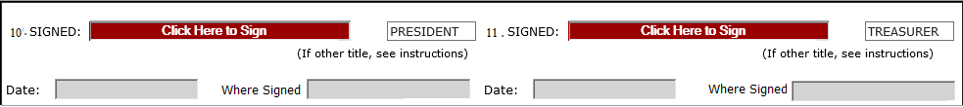

When the filer clicks on the field “**Click Here to Sign”** the following pop-up will be opened.

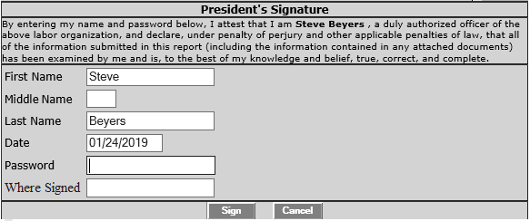

The pop-up will list the title of the filer on the header. The window will list the following disclaimer statement.

“**By entering my name and password below, I attest that I am <First Name Last Name>, a duly authorized officer of the above labor organization, and declare, under penalty of perjury and other applicable penalties of law, that all of the information submitted in this report (including the information contained in any attached documents) has been examined by me and is, to the best of my knowledge and belief, true, correct, and complete.”**

Following fields will be listed in this pop-up window. The filer should be able to modify any information listed in this pop-up.

* **First Name** – This will a text field listing the first name of the person signing the report. The filer should be able to modify this field before signing the form.
* **Middle Name** – This will be a text field listing the middle name of the filer. The filer should be able to modify this field before signing the form.
* **Last Name** – This will be text field listing the last name of the filer. The filer should be able to modify this field before signing the form.
* **Date** – This will be a date field listing the current date in DD/MM/YYYY format. The filer should be able to modify this field before signing the form.
* **Password** – The field will capture the password for the account which the filer used while login to the EFS system.
* **Where Signed** – This will be a text field to enter the city and state information.
* **Sign** – If the filer has entered the valid password and all required details, clicking this button will sign the form. If a wrong password is entered or any required is missing, the system will give a message to the filer regarding the error and will not allow the filer to sign the form (See validation document for the error message).
* **Cancel** – This button will close the pop-up window

The following titles will be listed against each signature fields. The requirements for each title fields are listed below:

* **President’s Title** - The system shall pre-fill the designation of first signing official as ‘**President’**. The user should be able to modify the title before signing the form. Modifying the title will remove signatures and the form needs to be revalidated to enable the signature field.
* **Treasurer’s Title** - The system shall pre-fill the designation of second signing official as ‘**Treasurer’**. The user should be able to modify the title before signing the form. Modifying the title will remove signatures and the form needs to be revalidated to enable the signature field.

The Date and Where Signed will be listed against each signature fields. The requirements for these fields are listed below:

* **Date** - This field is populated with the date when the filer successfully signs the form. The system list the date on the pop-up window that captures the signature. The filer will be able to modify the date only when signing the form. Once the system captured the signature, the date fields will be read-only.
* **Where Signed** - This field is populated with the telephone number of the filer when the filer successfully signs the form. This phone number shall be editable only through the pop-up window that captures the signature. Once the system captured the signature, the field will be read-only.

Since the Print Preview is not available for this report, the standard EFS pop-up message displayed when capturing the second signature is not required.

# Other functionalities

The following functionalities are common to all the annual reports. Simplified Annual Report will use the same architecture to perform these functionalities.

**Save** – This button will save the current page and the data will be inserted to the EFS temporary database.

**Validate** – This button will all the pages, except the Main page performs the following.

1. Saves the page data to the EFS temporary database
2. Trigger a page level validation and returns any error to be corrected.

**Submit** – This button will selected as the final step to submit the Simplified Annual Report. The form can be submitted only after the filers signed the form. Once the filers signed the form and clicked on the **Submit** button, the data will be moved from the temporary database to the eLORS database.

**Form Instructions** – This button will open the instructions page in a new tab. DIS will be responsible for providing the HTML version of the Simplified Annual Report instructions.

**EFS Help** – This button will open the EFS Help page in a new tab.

# Requirements Revisions History

During the requirements discussions and review meetings, requirements for certain sections have been changed. The details are listed in the following table.

| **Date** | **Change Nature** | **Stakeholders Involved** | **Decision/Changes Provided** | **Approved By** | **Comments** |
| --- | --- | --- | --- | --- | --- |
| 1/24/2018 | Requirements have been reviewed on. | Andrew Auerbach  Andrew Davis  Avieon Morgan  Christian Myers  Dyana Aziz  Ethan Dazelle  Henry Kalinowski  James Haskins  Michael Delaney  Bineeta Adityan  Christopher Wiederkehr  Ran Li  Rahul Gupta | Meeting minutes attached | Andrew Auerbach |  |